# Day 9&10

**Task 1: Dijkstra’s Shortest Path Finder**

Code Dijkstra’s algorithm to find the shortest path from a start node to every other node in a weighted graph with positive weights.

**Program:**

package Assignments.Day9and10;

import java.util.*;

class Task1 {

private int V;

private List<Edge>[] adj;

static class Edge {

int dest;

int weight;

Edge(int dest, int weight) {

this.dest = dest;

this.weight = weight;

}

}

public Task1(int v) {

V = v;

adj = new ArrayList[v];

for (int i = 0; i < v; ++i) {

adj[i] = new ArrayList<>();

}

}

public void addEdge(int u, int v, int weight) {

adj[u].add(new Edge(v, weight));

adj[v].add(new Edge(u, weight));

}

public void dijkstra(int start) {

PriorityQueue<Edge> pq = new PriorityQueue<>(Comparator.comparingInt(e -> e.weight));

int[] dist = new int[V];

Arrays.fill(dist, Integer.MAX_VALUE);

dist[start] = 0;

pq.add(new Edge(start, 0));

while (!pq.isEmpty()) {

Edge curr = pq.poll();

int u = curr.dest;

for (Edge neighbor : adj[u]) {

int v = neighbor.dest;

int weight = neighbor.weight;

if (dist[u] + weight < dist[v]) {

dist[v] = dist[u] + weight;

pq.add(new Edge(v, dist[v]));

}

}

}

System.out.println("Shortest distances from node " + start + ":");

for (int i = 0; i < V; ++i) {

System.out.println("Node " + i + ": " + dist[i]);

}

}

public static void main(String[] args) {

Task1 graph = new Task1(6);

graph.addEdge(0, 1, 2);

graph.addEdge(0, 2, 4);

graph.addEdge(1, 2, 1);

graph.addEdge(1, 3, 7);

graph.addEdge(2, 4, 3);

graph.addEdge(3, 4, 1);

graph.addEdge(3, 5, 5);

int startNode = 0;

graph.dijkstra(startNode);

}

}

**Output:**

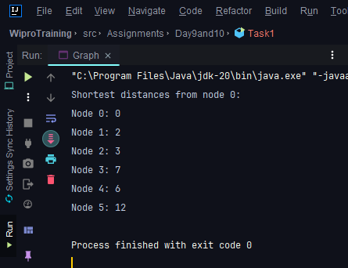

**Task 2: Kruskal’s Algorithm for MST**

Implement Kruskal’s algorithm to find the minimum spanning tree of a given connected, undirected graph with non-negative edge weights.

**Program:**

package Assignments.Day9and10;

import java.util.*;

class Task2 {

private final int V;

private final List<Edge> edges;

static class Edge {

int src;

int dest;

int weight;

Edge(int src, int dest, int weight) {

this.src = src;

this.dest = dest;

this.weight = weight;

}

}

public Task2(int v) {

V = v;

edges = new ArrayList<>();

}

public void addEdge(int u, int v, int weight) {

edges.add(new Edge(u, v, weight));

}

// Find set of vertex i

private int find(int i, int[] parent) {

if (parent[i] != i)

parent[i] = find(parent[i], parent);

return parent[i];

}

// Does union of i and j. Returns false if i and j are already in the same set.

private boolean union(int i, int j, int[] parent) {

int a = find(i, parent);

int b = find(j, parent);

if (a == b)

return false;

parent[a] = b;

return true;

}

// Finds MST using Kruskal's algorithm

public void kruskalMST() {

edges.sort(Comparator.comparingInt(e -> e.weight));

int[] parent = new int[V];

for (int i = 0; i < V; i++)

parent[i] = i;

int minCost = 0;

List<Edge> mstEdges = new ArrayList<>();

for (Edge edge : edges) {

if (union(edge.src, edge.dest, parent)) {

mstEdges.add(edge);

minCost += edge.weight;

}

}

System.out.println("Minimum Spanning Tree Edges:");

for (Edge edge : mstEdges) {

System.out.println(edge.src + " - " + edge.dest + " (weight: " + edge.weight + ")");

}

System.out.println("Total cost of MST: " + minCost);

}

public static void main(String[] args) {

Task2 graph = new Task2(6);

graph.addEdge(0, 1, 2);

graph.addEdge(0, 2, 4);

graph.addEdge(1, 2, 1);

graph.addEdge(1, 3, 7);

graph.addEdge(2, 4, 3);

graph.addEdge(3, 4, 1);

graph.kruskalMST();

}

}

**Output:**

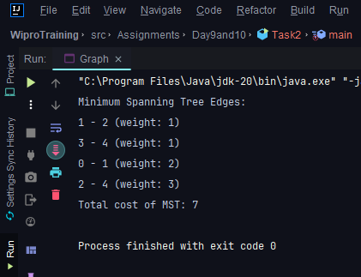

**Task 3: Union-Find for Cycle Detection**

Write a Union-Find data structure with path compression. Use this data structure to detect a cycle in an undirected graph.

**Program:**

package Assignments.Day9and10;

**class UnionFind** {

private int[] parent;

private int[] rank;

public UnionFind(int n) {

parent = new int[n];

rank = new int[n];

for (int i = 0; i < n; ++i) {

parent[i] = i;

rank[i] = 0;

}

}

public int find(int x) {

if (parent[x] != x) {

parent[x] = find(parent[x]); // Path compression

}

return parent[x];

}

public void union(int x, int y) {

int rootX = find(x);

int rootY = find(y);

if (rootX != rootY) {

if (rank[rootX] < rank[rootY]) {

parent[rootX] = rootY;

} else if (rank[rootX] > rank[rootY]) {

parent[rootY] = rootX;

} else {

parent[rootY] = rootX;

rank[rootX]++;

}

}

}

}

package Assignments.Day9and10;

import java.util.ArrayList;

import java.util.List;

**class Graph** {

private final int V;

private final List<int []> edges;

public Graph(int v) {

V = v;

edges = new ArrayList<>();

}

public void addEdge(int u, int v) {

edges.add(new int[]{u, v});

}

public boolean hasCycle() {

UnionFind uf = new UnionFind(V);

for (int[] edge : edges) {

int u = edge[0];

int v = edge[1];

if (uf.find(u) == uf.find(v)) {

return false;

}

uf.union(u, v);

}

return true;

}

}

**public class Task3** {

public static void main(String[] args) {

Graph graph = new Graph(4);

graph.addEdge(0, 1);

graph.addEdge(1, 2);

graph.addEdge(2, 3);

boolean hasCycle = graph.hasCycle();

System.out.println("Graph has a cycle: " + hasCycle);

}

}

**Output:**

